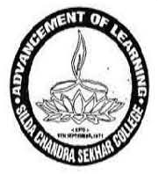
E-mail: silda_cscollege@yahoo.com
: (03221) 205357/ : 03221 252311
Website: www.scscollege.ac.in

SILDA CHANDRASEKHAR COLLEGE

ESTD : 9.11.1971

P.O. - Silda Pin-721515 Dist: Jhargram (W.B.).

Ref: Date: 18.10.20
N O T I C E
It is notified to all concerned that the online classes for 3rd and 5th semester students will not be held w.e.f. 19.10.20 to 1.11.20 on account of Durga Puja festival and Lakshmi Puja. Online classes will resume on 2.11.20 as per the routine.

Sd/- Dr. Sujata Tewari
Vice Principal
Silda C S College

